**Assignment – 2**

**Write Below Java programs:**

1. **Helloworld**

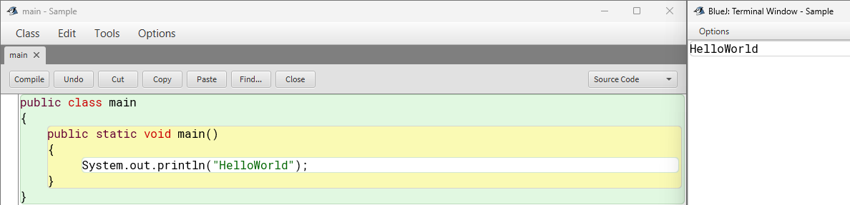

1. **Add Two numbers**

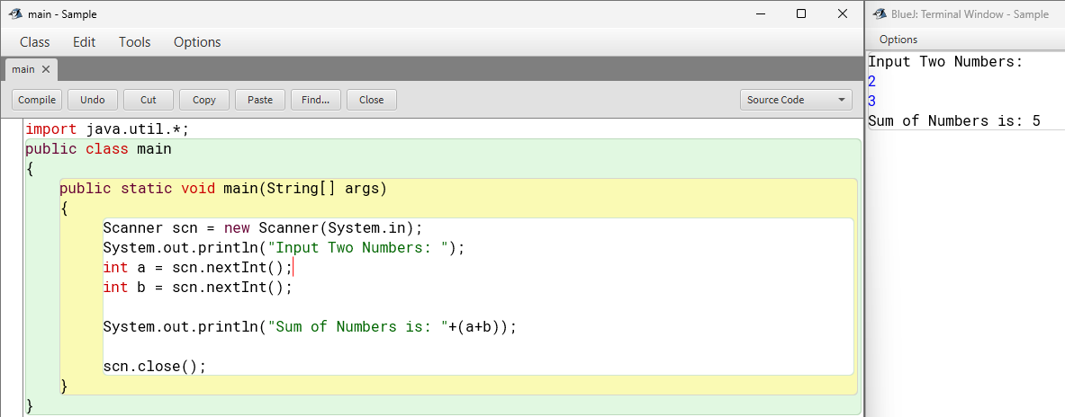

1. **square of a number**

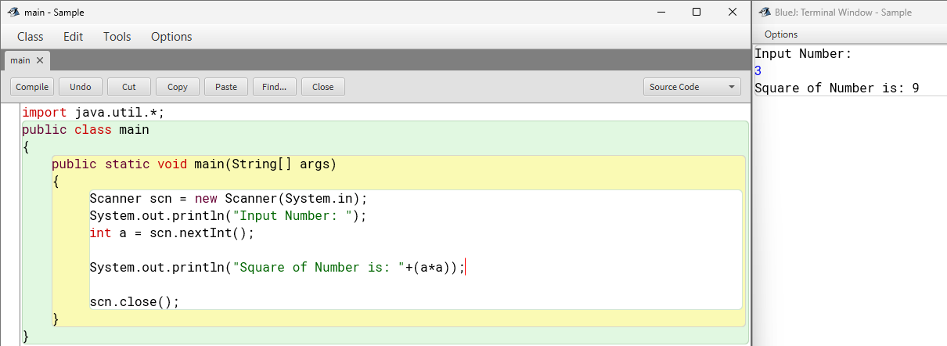

1. **check positive or negative**

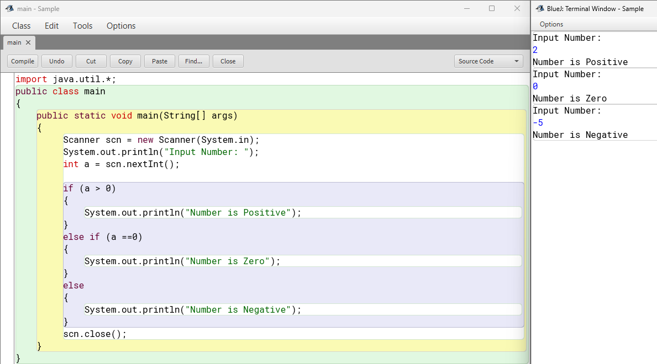

1. **Find largest of two numbers**

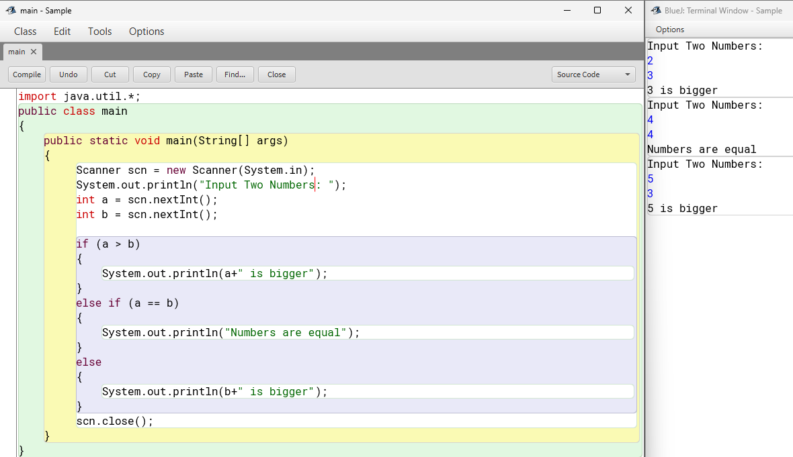

1. **convert celcius to Fahrenheit**

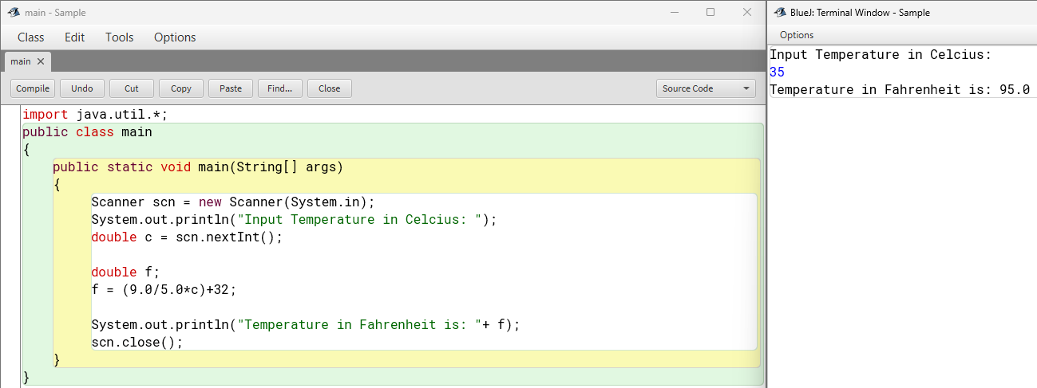

1. **Print numbers from 1 to 5**

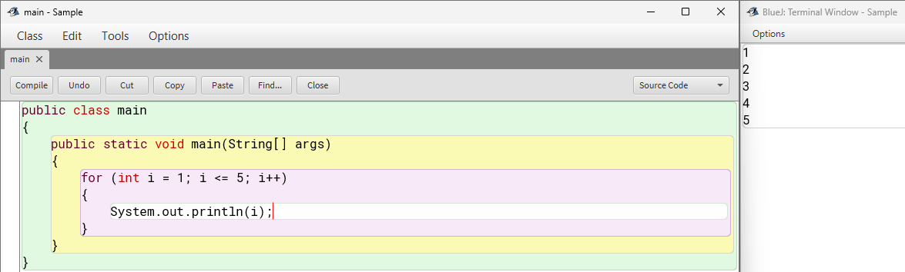

1. **check if a number is even or odd**

